H.T No
Regulations:
A20

Sreenidhi Institute of Science and Technology
(An Autonomous Institution)
Code No:8K404 Date: 31-Jan-2025 (AN)

B.Tech II-Year II- Semester External Examination, Jan - 2025 (Supplementary)
MECHANICS OF MATERIALS (CIVIL)

Time: 3 Hours Max.Marks:70

Note: a) No additional answer sheets will be provided.
b) All sub-parts of a question must be answered at one place only, otherwise it will not be valued.
c) Missing data can be assumed suitably.

Bloom's Cognitive Levels of Learning (BCLL)

Remember | L1 | Apply | L3 | Evaluate | L5
Understand | L2 | Analyze | L4 | Create | L6

Part - A Max.Marks:20
Answer all QUESTIONS

 |  | BCLL | CO(s) | Marks
1 | Define radial pressure in thin cylinder. | L1 | CO1 | [2M]
2 | State Hill criteria. | L1 | CO2 | [2M]
3 | What is SFD and BMD? | L2 | CO3 | [2M]
4 | Determine the indeterminacy of cantilever beam and fixed beam. | L2 | CO4 | [2M]
5 | Write about pure bending. | L1 | CO5 | [2M]
6 | Mention the stresses which are responsible for the failure of a column. | L2 | CO6 | [2M]
7 | Differentiate between circumferential stress and hoop stress. | L1 | CO1 | [2M]
8 | Define perfect frame and imperfect frame. | L1 | CO3 | [2M]
9 | Differentiate between equivalent length and effective length. | L2 | CO5 | [2M]
10 | What are elasticity and plasticity? | L1 | CO6 | [2M]
Part – B Max.Marks:50
ANSWER ANY FIVE QUESTIONS. EACH QUESTION CARRIES 10 MARKS.

 |  |  | BCLL | CO(s) | Marks
11. |  | Determine the force in each member of the loaded truss by Method of Joints.  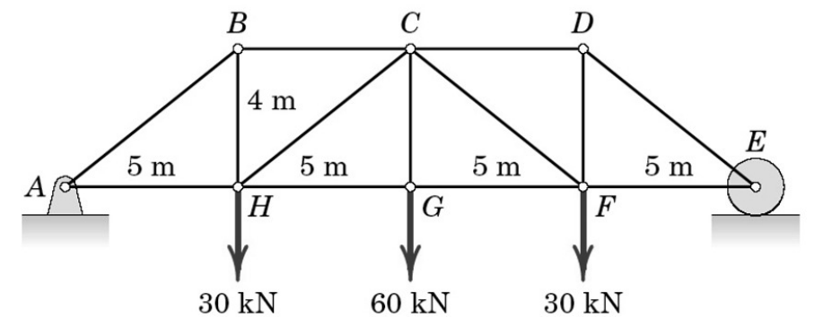 | L2 | CO1 | [10M]
12. | a) | Explain the significance of the stress tensor in describing the state of stress at a point. | L2 | CO2 | [5M]
 | b) | Explain maximum shear stress theory and strain energy theory. | L2 | CO2 | [5M]
13. | a) | Explain the relationship between the bending moment and the curvature of a beam. | L2 | CO3 | [5M]
 | b) | A simply supported beam of span 6 m carries two point loads of 30 kN each at 2 m and 4 m from left support. The beam also carries a U.D.L. of 20 kN/m between two point loads. Draw S.F.D. and B.M.D. | L3 | CO3 | [5M]
14. | a) | Differentiate between statically determinate and indeterminate trusses with examples. | L2 | CO4 | [5M]
 | b) | For the bar shown in Figure, determine the normal stresses in different parts. Assume the diameters as d_{AB} = d_{CD} = 20 mm, d_{BC} = 40 mm.  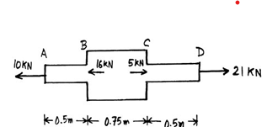 | L3 | CO4 | [5M]
15. |  | Derive the equation for moment curvature relationship and write the assumptions made in the equation. | L4 | CO5 | [10M]
16. |  | A hollow C.I column whose outside diameter is 200 mm has a thickness of 20 mm. It is 4.5 m long and is fixed at both ends. Calculate the safe load by using Rankine’s formula with a factor of safety 4.0. Calculate the slenderness ratio and ratio of Euler’s and Rankine’s critical loads. For cast iron σ_{c}=550 N/mm², a=1/1600 and E=8x10⁴ N/mm². | L2 | CO6 | [10M]
17. | a) | Find the thickness of the pipe due to an internal pressure of 10 N/mm² if the permissible stress is 120 N/mm² and the diameter of the pipe is 750 mm | L3 | CO1 | [4M]
 | b) | Write the general form of the stress tensor for a three-dimensional stress state | L2 | CO2 | [3M]
 | c) | Define a slender member and provide examples of its applications. | L2 | CO3 | [3M]
18. | a) | A 2 m long aluminum bar with a cross-sectional area of 50 mm² is subjected to an axial load of 10 kN. Calculate the deformation if Young's modulus of aluminum is 70 GPa. | L3 | CO4 | [4M]
 | b) | Determine the strain energy due to axial load in a member. | L2 | CO5 | [3M]
 | c) | Write the limitations of Euler’s formula. | L2 | CO6 | [3M]
 |  | Write the relation between Equivalent length and actual length for all end conditions of column.
-- 00 -- 00 –

